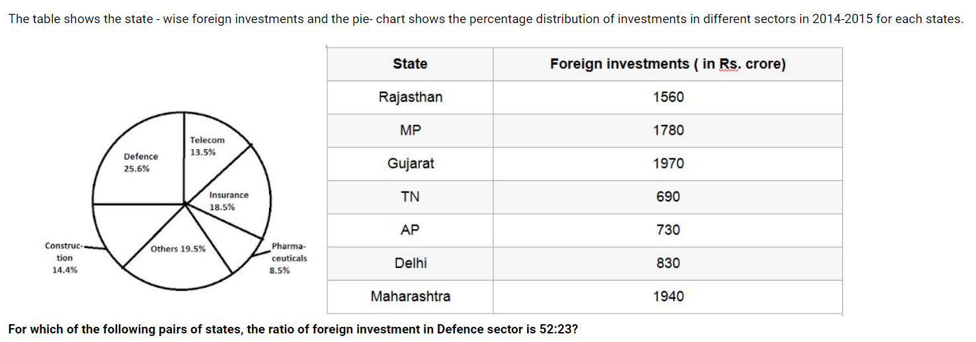

Telecom Sector = 13.5%

Defence Sector = 25.6%

Construction sector = 14.4%

Others = 19.5%

Pharmaceutical =8.5%

Insurance = 18.5%

1. **What is the total foreign investment in Other sectors by all the given states together? (in Rs. Crore)**

1438.5

C:\Users\hp\AppData\Local\Temp\ksohtml8384\wps39.wmf

1648.5

C:\Users\hp\AppData\Local\Temp\ksohtml8384\wps40.wmf

1752.5

C:\Users\hp\AppData\Local\Temp\ksohtml8384\wps41.wmf

1852.5

Other sectors = 19.5%

9500 * 19.5/100 = 1852.5

2. **For which of the following pairs of states, the ratio of foreign investment in Defence sector is 52:23?**

MP, TN

Rajasthan, TN

MP, AP

Maharashtra, TN

1780 : 690

1560:690 = 52:23

3. **The foreign investment in Insurance sector in Rajasthan is approximately what percent of the foreign investment in Construction sector in Maharashtra?**

107%

C:\Users\hp\AppData\Local\Temp\ksohtml8384\wps45.wmf108%

C:\Users\hp\AppData\Local\Temp\ksohtml8384\wps46.wmf101%

C:\Users\hp\AppData\Local\Temp\ksohtml8384\wps47.wmf103%

(1560 * 18.5/100 )/(1940 * 14.4/100)*100

((1560*18.5)/(1940*14.4))*100

103%

4. **What is the ratio of the foreign investment in Defence sector in Gujarat to that in Construction and Insurance sector together in MP?**

25316:28391

25216:29281

25216:29381

27246:27284

(1970*25.6/100)/ (1780*(14.4+18.5)/100)

50432 / 58562

25216:29281

5.**The foreign investment in pharmaueutical sector in AP is approximately what percent less than the foreign investment in Telecom sector in delhi?**

a) 44.6%

b)49.6%

c)45.8%

d)47.6%

730 * 8.5/100 = 62.05

830 * 13.5/100=112.05

Percentage decrease =((112.05-62.05)/112.05) *100

50/112.05*100=44.6%

A)If the data in statement I alone are sufficient to answer the question , while the data in statement II alone are not sufficient to answer the question

B) If the data in statement II alone are sufficient to answer the question , while the data in statement I alone are not sufficient to answer the question

C)If the data either in statement I alone or in statement II alone are sufficient to answer the question

.D)If the data in both the statement I & II together are not sufficient to answer the question.

E)If the data in both statement I & II together are necessary to answer the question

A customer is given two successive discounts on an article worth Rs 1000 . Find the second discount

I)The selling price of the article is Rs 680

II)The first discount is 15 %

A

D

B

C

E

C.P = 1000

1)S.P = 680

2)Frist discount is 15%

1000*15/100= 150

850 – 680 = 170

850 * x% = 170

X=170*100/850=20%

A, B, C, D have to stand in a queue in descending order of their heights. Who stands first?

I. D was not the last, A was not the first.

II. The first is not C and B was not the tallest

A

C:\Users\hp\AppData\Local\Temp\ksohtml8384\wps55.wmfD

C:\Users\hp\AppData\Local\Temp\ksohtml8384\wps56.wmfB

C:\Users\hp\AppData\Local\Temp\ksohtml8384\wps57.wmfC

C:\Users\hp\AppData\Local\Temp\ksohtml8384\wps58.wmfE

D A

C B

A boat takes 4 hours to go from point A to B downstream and back from B to A upstream. What is the speed of the current ?

I)The distance between A and B is 27 km

II)The speed of the boat in still water is 18 kmph

E

C:\Users\hp\AppData\Local\Temp\ksohtml8384\wps59.wmfD

C:\Users\hp\AppData\Local\Temp\ksohtml8384\wps60.wmfC

C:\Users\hp\AppData\Local\Temp\ksohtml8384\wps61.wmfA

B

T – 4hrs

S.U = (u-v)

S.D=(u+v)

D=27km

2)s.u = (18-v)

s.D=(18+v)

T=D/S

4 = 27/(18-v)+(2

Is x divisible by 12?

1. x is divisible by 3

2. x is divisible by 4

C

C:\Users\hp\AppData\Local\Temp\ksohtml8384\wps64.wmfE

C:\Users\hp\AppData\Local\Temp\ksohtml8384\wps65.wmfD

C:\Users\hp\AppData\Local\Temp\ksohtml8384\wps66.wmfB

C:\Users\hp\AppData\Local\Temp\ksohtml8384\wps67.wmfA

12 – both 3 & 4

What are the speeds two trains travels with 80 mts and 85 mts long respectively? (Assume that former is faster than later)

1. they take 75 seconds to pass each other in opposite direction.

2. they take 5 seconds to pass each other in same direction

D

C:\Users\hp\AppData\Local\Temp\ksohtml8384\wps68.wmfC

C:\Users\hp\AppData\Local\Temp\ksohtml8384\wps69.wmfE

C:\Users\hp\AppData\Local\Temp\ksohtml8384\wps70.wmfB

A



X & y

S = D/T

X+Y =165/75 ->1

X-Y = 5/5 -> 2

**Statements:**

Some triangles are square.

All squares are cube.

No cube is circle.

Some circles are rectangle.

**Conclusion:**

I.All triangles being circle is a possibility.

II.No square is circle.

III.Some triangle is cube.

None follows

C:\Users\hp\AppData\Local\Temp\ksohtml8384\wps75.wmf

Only II

C:\Users\hp\AppData\Local\Temp\ksohtml8384\wps76.wmf

II and III

C:\Users\hp\AppData\Local\Temp\ksohtml8384\wps77.wmf

Only III

C:\Users\hp\AppData\Local\Temp\ksohtml8384\wps78.wmf

I and III

There are six cards in which it has two king cards. all cards are turned down and two cards are opened. a) What is the possibility to get atleast one king. b) What is the possibility to get two kings

6cards – 2king 4 other

P(a) = F.O/T.O

((2c1*4c1)+(2c2*4c0))/6c2

(2*4+1)/(6*5/2*1)=9/15=3/5

2c2/6c2=1/15

**Statements:**

A.All laptops are mobiles.

B.All tablets are laptops.

C.No laptop is ipad.

D.All mobiles being ipads is possibility.

E.All ipads being mobiles is possibility.

F.Some ipads are tablets.

BCD

C:\Users\hp\AppData\Local\Temp\ksohtml8384\wps72.wmfABD

C:\Users\hp\AppData\Local\Temp\ksohtml8384\wps73.wmfABF

C:\Users\hp\AppData\Local\Temp\ksohtml8384\wps74.wmfACE

**Statements:**

No black is orange.

All yellow is orange.

Some yellow is green.

All green is pink.

**Conclusion:**

I.Some orange are pink.

II.All orange being yellow is a possibility.

III.Some green is not black.

All follows

C:\Users\hp\AppData\Local\Temp\ksohtml8384\wps79.wmf

Only I

C:\Users\hp\AppData\Local\Temp\ksohtml8384\wps80.wmf

I and III

C:\Users\hp\AppData\Local\Temp\ksohtml8384\wps81.wmf

Only II

C:\Users\hp\AppData\Local\Temp\ksohtml8384\wps82.wmf

Only III

**Statements:**

Some cats are white.

Some white are dog.

All dogs are blue.

No dog is monkey.

All monkeys are tall.

**Conclusion:**

I.Some tall is not dog.

II.Some cat is dog.

III.All blue being monkeys is a possibility.

II and III

C:\Users\hp\AppData\Local\Temp\ksohtml8384\wps83.wmf

All follows

C:\Users\hp\AppData\Local\Temp\ksohtml8384\wps84.wmf

Only II

C:\Users\hp\AppData\Local\Temp\ksohtml8384\wps85.wmf

Only I

C:\Users\hp\AppData\Local\Temp\ksohtml8384\wps86.wmf

I and III

Is the product of x and y greater than 60?

1. The sum of x and y is greater than 60.

2. Each of the variables is greater than 2.

A

C:\Users\hp\AppData\Local\Temp\ksohtml8384\wps88.wmf

B

C:\Users\hp\AppData\Local\Temp\ksohtml8384\wps89.wmf

E

C:\Users\hp\AppData\Local\Temp\ksohtml8384\wps90.wmf

C

C:\Users\hp\AppData\Local\Temp\ksohtml8384\wps91.wmf

D

1. X = 0.5 y =60

X+y = 60.5

X = 5 y =60 x+y=65

Xy = 300

2)x = 5 y = 4

Xy=20

X=10 y=9

Xy = 90

X+Y>60

X&Y>2

X = 3

Y = 57

Is w a Whole number?

Statement 1: 3w is an Odd number.

Statemet 2: 2w is an positive Even number

B

D

E

A

C

3w

W = 1

3*1 = 3

W = 1/3

3*1/3 = 1

a and b are two positive numbers. How many of them are odd?

I. Multiplication of b with an odd number gives an even number.

II.a2 – b is even

E

C:\Users\hp\AppData\Local\Temp\ksohtml8384\wps92.wmfB

C:\Users\hp\AppData\Local\Temp\ksohtml8384\wps93.wmfA

C:\Users\hp\AppData\Local\Temp\ksohtml8384\wps94.wmfD

C:\Users\hp\AppData\Local\Temp\ksohtml8384\wps95.wmfC